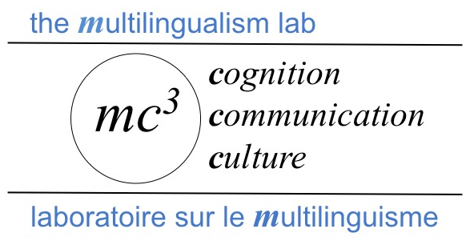

LANGUAGE BACKGROUND QUESTIONNAIRE

Name: _______________________________ Date: _______________________
Age: __________________ Sex: M ___ F___
- If you are a student:
What is your field of study? ___________________________________________
What degree are you pursuing? College (Cégep/Diploma/etc.)___ Bachelor___ MA/PhD/etc.___
2. Where were you born? City:__________________ Country: ______________________
3. What do you consider to be your first learned language?
English ___ French ___ Other (specify) ________________
4. What do you consider to be your second learned language?
English ___ French ___ Other (specify) ________________
5. At what age did you learn your second language? Age of ________ years old
6. What language do you consider to be your dominant language (the language you are most comfortable in)?

English ___ French ___ Other (specify) ________________
7. What language do you speak at home now? _______________________________________

8. What is the first language of your: Mother? ____________ Father? ________________
9. What was the language of instruction of the school you attended? (Check all appropriate):
- Preschool: English___ French___ French Immersion___ Other (specify)______
- Elementary school: English___ French___ French Immersion___ Other (specify)______
- Middle/High school: English___ French___ French Immersion___ Other (specify)______
- College/Cégep/Diploma: English___ French___ Other (specify)______
- University: English___ French___ Other (specify)______

10. If you are not currently a student, what is the highest level of education you have completed:
High school___ College/Cégep/Diploma___ University: Bachelor___ University: MA/PhD/etc.___

11. Do you have a known hearing impairment? Yes ___ No ___

12. What percentage of your interactions are in each language (total should = 100%):
English ______ %? French ______%? Other _______%?

13. Please rate your level of ability for each of the four skills listed below by using the following rating scheme and circling the appropriate number in the boxes below:

1 = little or no ability at all 2 = elementary 3 = moderate 4 = very good
5 = native or near native-like ability

Language | Speaking | Reading | Writing | Listening
English | 1 2 3 4 5 | 1 2 3 4 5 | 1 2 3 4 5 | 1 2 3 4 5
French | 1 2 3 4 5 | 1 2 3 4 5 | 1 2 3 4 5 | 1 2 3 4 5
Other (strongest language that is not English or French)  ____________ | 1 2 3 4 5 | 1 2 3 4 5 | 1 2 3 4 5 | 1 2 3 4 5

SPEAKING FRENCH, YOUR SECOND LANGUAGE
Please think about how well you can SPEAK French.
 | Now complete STEP 1.
 | STEP 1
First, read all the descriptions shown in this table and try to find the one description that best describes your ability to speak French.
Next, place a check mark "" in the box "" next to that one description that best indicates your ability to speak French.
 | I can express myself in all or almost all contexts, using all or nearly all expressions that native speakers typically use.
 | I can express myself on unfamiliar topics, although I don't always know the expressions that native speakers would typically use.
 | I can only speak about familiar topics.
 | I am limited to saying only simple things, such as asking for directions or answering short questions.
 | I cannot express very much at all in the language.
 | Now complete STEP 2.
 | STEP 2
 | Read the "A" and "B" boxes below. Then circle "A" or "B" to indicate how easy it is for you to speak French at the level you selected above.
 | A | At the level I selected, I generally speak more or less fluently and at a normal rate. |  | B | At the level I selected, I sometimes hesitate, have to search noticeably for words, or try to avoid making errors, or speak more slowly than I usually do.
UNDERSTANDING SPOKEN FRENCH, YOUR SECOND LANGUAGE
Please think about how well you can UNDERSTAND spoken French.
 | Now complete STEP 1.
 | STEP 1
First, read all the descriptions shown in this table and try to find the one description that best describes your ability to understand spoken French.
Next, place a check mark "" in the box "" next to that one description that best indicates your ability to understand spoken French.
 | I can understand native speakers in all or almost all contexts, including nearly all the expressions that native speakers typically use.
 | I can understand native speakers when they talk about unfamiliar topics, even though I may not always understand every expression they use.
 | I am limited to understanding native speakers only when they talk about familiar topics.
 | I can understand native speakers only when they talk about simple things, such as when they give directions or ask short questions.
 | I cannot understand others very much at all in the language.
 | Now complete STEP 2.
 | STEP 2
 | Read the "A" and "B" boxes below. Then circle "A" or "B" to indicate how easy it is for you to understand spoken French at the level you selected above.
 | A | At the level I selected, I generally understand speakers who speak fluently and at a normal speed. |  | B | At the level I selected, I sometimes have to ask people to slow down and repeat, or to speak more clearly, or to explain the meanings of some words.

