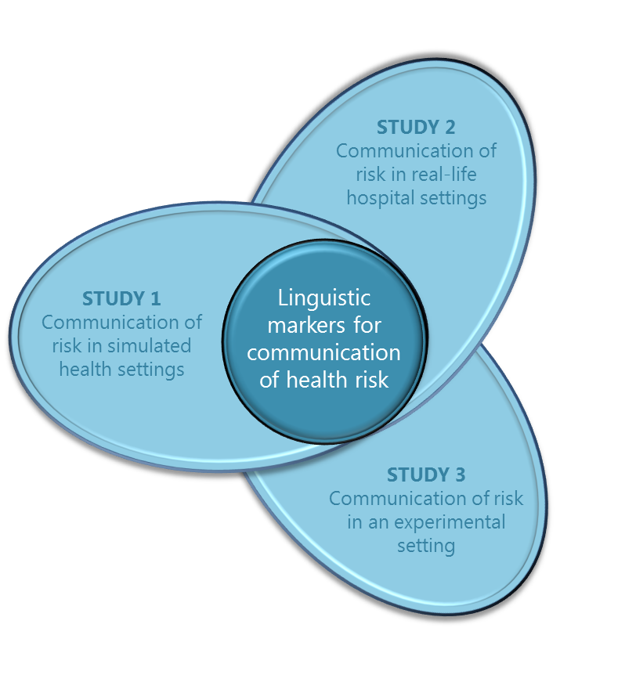

The studies carried out in Australia will focus on communication between people who have Chinese (Cantonese or Mandarin) and English as their first language. Canadian-based studies will focus on communication between people who speak English and French as their first language.

# The Health Communication Project

This Australian Research Council funded international collaboration is designed to understand communication of health risk when a health practitioner and patient do not share the same first language. It comprises three independent studies:

**Study 3 – Using healthcare relevant language expressions**

This laboratory based study investigates the way in which specific linguistic expressions may be processed differently by native versus non-native speakers. In particular, the study focuses on the ways in which people understand the meaning of *epistemic adverbs* such as “probably”, “possibly”, or “definitely” to convey risk in medical contexts.

**Progress update:** Data collection is complete and an abstract has been submitted for presentation at the American Association of Applied Linguistics conference in 2015.

**Study 2 – Communication of risk in the hospital setting**

This study investigates the same factors as Study 1, but in the context of real, hospital-based patient-clinician interactions.

**Progress update:** We will commence participant recruitment and data collection at Logan hospital shortly.

**Study 1 – A role-play simulation of communication effectiveness**

This study makes recordings of conversations between trainee health practitioners when they role-play a patient–clinician scenario. We predict that in role-plays where the first language is not shared, participants may experience difficulties in the social dynamics of communication, and problems accurately describing illness-associated risk.

**Progress update:** Scenarios have been developed and piloted on 230 QUT health faculty undergraduate students attending a communication and interpersonal skills course. A subset of interactions was also recorded for further analysis. These data will be used to inform the main role-play study with trainee health practitioners.

Health Communication Project

Newsletter

September 2014

Welcome to the inaugural health communication project newsletter!

We hope to keep you up to date with the team’s progress at QUT and UQ in Brisbane, and at Concordia University in Montreal.

volume 1 issue 1



**THE INVESTIGATORS**

**Chief Investigator**

A/Prof Renata Meuter

Queensland University of Technology

**Chief Investigator**

Emeritus Professor Cindy Gallois

University of Queensland

**Partner Investigator**

Professor Norman Segalowitz

Concordia University

**Partner Investigator**

Dr Andrew Ryder

Concordia University

# Ivan Chang joins the research team

Securing a prestigious Australian Postgraduate Award, Ivan Chang became the newest member of the team when he commenced his PhD in August. Ivan is co-supervised by Renata and Julia, and will incorporate Study 2 into his PhD. His first research task is to meet the directors of nursing and the nurse unit managers, so if you are based at one of our partner hospitals, expect to hear from Ivan shortly!









# Canadian partner visits Brisbane

We were thrilled to have Canadian partner investigator Professor Norman Segalowitz visit us in Brisbane this July and August. Norman is an international expert in second language learning and communication, and combined his visit to QUT with a talk on second language acquisition at the International Association of Applied linguistics conference held in Brisbane, as well managing to fit in a trip to Queensland’s beautiful Great Barrier Reef! The Health Communication team were also very productive during Norman’s visit, completing the analysis for Study 3 and submitting an abstract for the 2015 American Association for Applied Linguistics (AAAL) conference!



**THE RESEARCH TEAM**

**Research Associate:** Dr Julia Hocking

Queensland University of Technology

**Associate Investigator:** Dr Bernadette Watson

University of Queensland

**Research Assistant / PhD Student:** Ms Yue Zhao

Concordia University

**Research Assistant / PhD student:** Mr Ivan Chang

Queensland University of Technology

**Research Assistant:** Ms Cathy Cleary

Queensland University of Technology

**Research Assistant:** Mr Vincent Tam

Queensland University of Technology

# UQ Winter Scholarship

During the July intersemester break, Jane Wong – a 4th year honours psychology student at UQ – came to work on the project. Jane was awarded a winter scholarship from UQ, and developed some excellent health related scenarios to be used in the simulated role-play for Study 1. We have now piloted the scenarios with undergraduate participants from a QUT interpersonal and communication skills course, and we will let you know the results of the pilot study in the next newsletter!

# Participate in the research

Are you a health practitioner at one of our partner hospitals? Would you like to participate in the research, or find out more information?

Contact us by email: [healthcommunication@qut.edu.au](mailto:healthcommunication@qut.edu.au) or phone us at our Brisbane office on: +61 7 3138 4610.